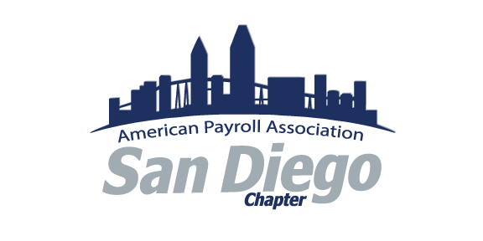

Preparing for the CPP Test - January 2024 Workshop
Workshop Sponsored by the SDAPA

Spring 2024 Test Registration/Test Dates:
Registration: November 6, 2023 - April 19, 2024
*Exam: January 8 - April 20, 2024
*Exams administered from September 9, 2023 through September 6, 2024, feature questions based on federal laws and regulations in effect as of January 1, 2023.

Workshop 1 – January 6, 2024 9am – 12pm PST
Online only
I – Core Payroll Concepts 24%
- Worker Status
- Fair Labor Standards Act
- Employment Taxes
- Employee Benefits
- Employee/Employer Forms
- Professional Responsibility
- Methods and Time of Pay
II – Compliance / Research and Resources 16%
- Escheatment
- Legislative and Regulatory Requirements
- Reporting
- Record Retention
- Penalties
- Global
- Multi-state Taxation / Reporting
IV – Payroll Process and Supporting Systems and Administration 12%
- Maintain Master File Components
- Concepts and Functionalities
- Business Continuity Plan
- Technology Evaluation
- Upgrade / Implement Knowledge
- System Maintenance / Updates
- System / Project Implementations

Workshop 2 – January 13, 2024 9am – 12pm PST
Online only
III – Calculation of the Paycheck 20%
- Compensation / Benefits
- Fringe Benefits
- Involuntary Deductions / Taxes
- Voluntary Deductions
- Employer Taxes and Contributions
- Total Payroll

Workshop 3 – January 20, 2024 9am – 12pm PST
Online only
V – Payroll Administration and Management 10%
- Policies and Procedures
- Management Skills and Practices
- Customer Service and Communications
- Staffing, Employee Development, and Core Competencies
VI – Audits 9%
- Internal Controls
- Payroll System Controls
- Accounting System Controls
- Audit Policies and Procedures
- Third Party Controls
VII – Accounting 9%
- Financial Reporting
- Accounting Principles
- Payroll Journal Entries
- Accounting Reconciliation

Workshop 4 – January 27, 2024 – 9am – 11am PST
Online Only
Review and Practice Test

