San Diego Chapter
of the American Payroll Association

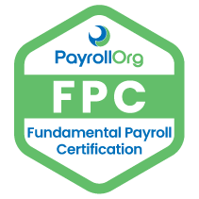
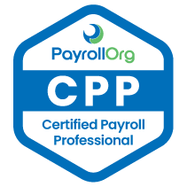

2023 Fall CPP Bootcamps
August 12 from 9am - 1pm online (registration deadline 8/9/23)
August 19 from 9am - 1pm online (registration deadline 8/16/23)
Registration required:
Free to Members, $50 Non-Members (per session)
Become a member for $50/annual
www.sandiegochapterapa.org

2023 Fall CPP Testing Registration is July 5 – Oct 6, 2023
Exam Dates September 9 – October 7, 2023

